

**The University of Azad Jammu and Kashmir,**

**Muzaffarabad**

|  |  |
| --- | --- |
| Name | Kamal Ali Akmal |
| Course Name | Operating System |
| Submitted to | Engr. Sidra Rafique |
| Semester | 3rd |
| Session | 2024-2028 |
| Roll No | 2024-SE-38 |
| Lab No | 01 |
| Submission date | 24 October 2025 |

**Task Manager:**

The Windows Task Manager is a powerful tool packed with useful information, from your system’s overall resource usage to detailed statistics about each process.

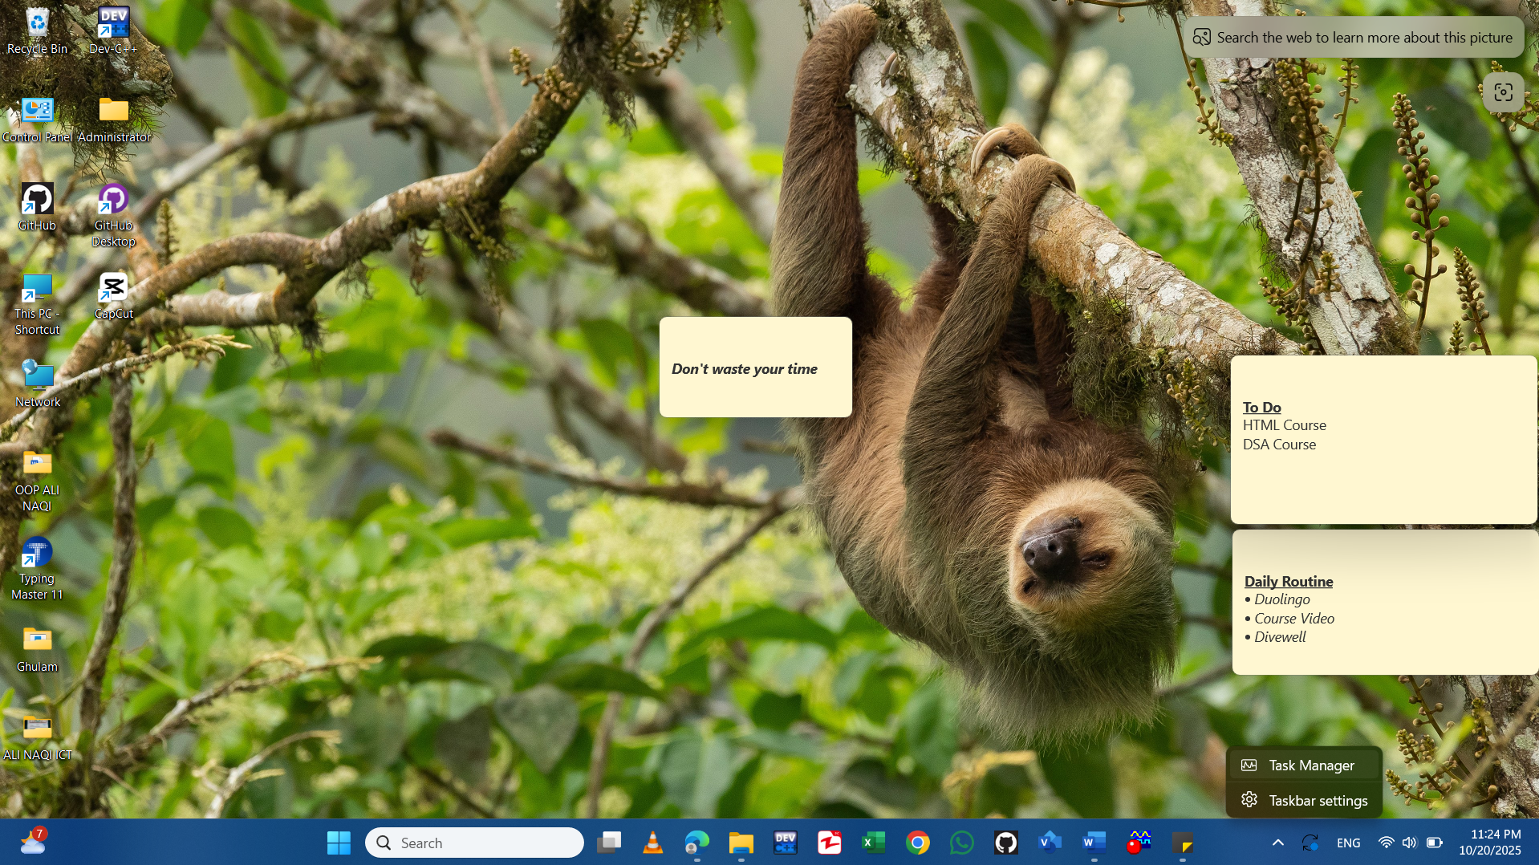

This shows you how many CPU (central processing unit) resources are currently in use on your system, and you can mouse over it to see memory, disk, and network usage Processes show a list of running applications and background processes on your system along with CPU, memory, disk, network, GPU, and other resource usage information.

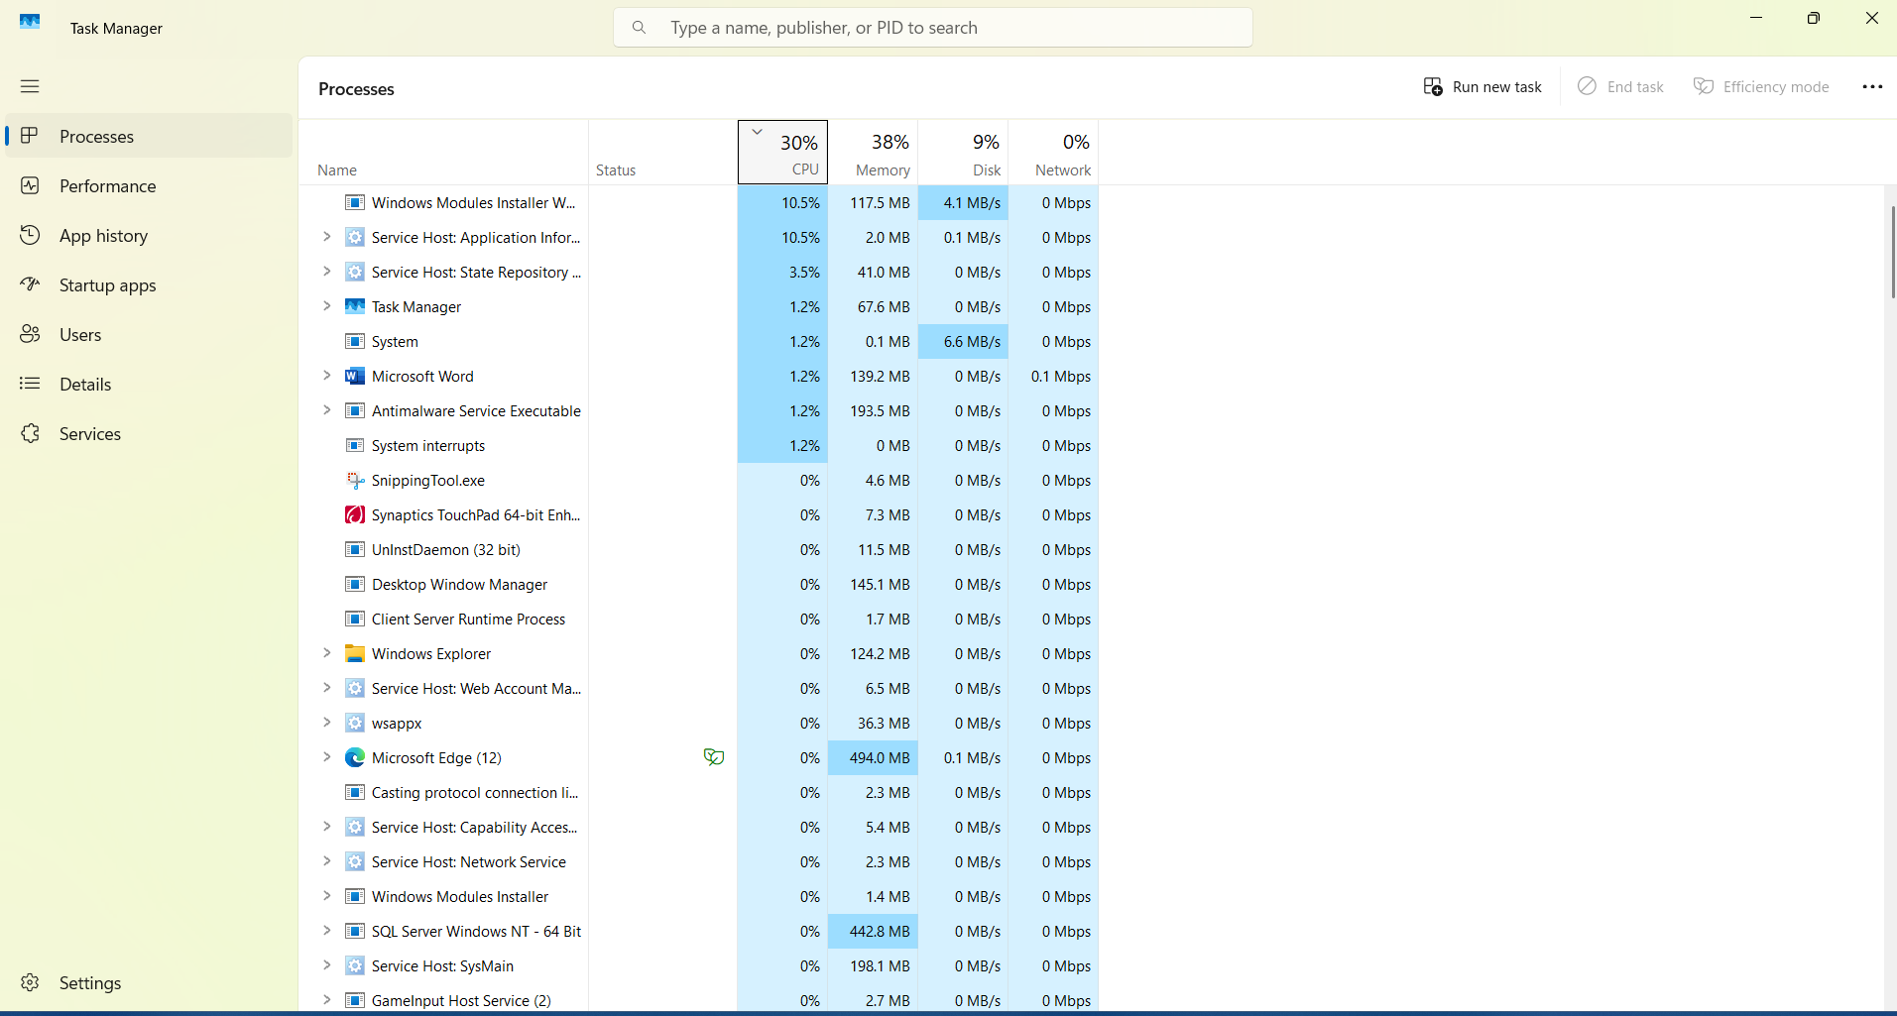

**Performance:** shows real-time graphs showing total CPU, memory, disk, network, and GPU resource usage for your system. You’ll find many other details here, too, from your computer’s IP to the model names of your computer’s CPU and GPU.

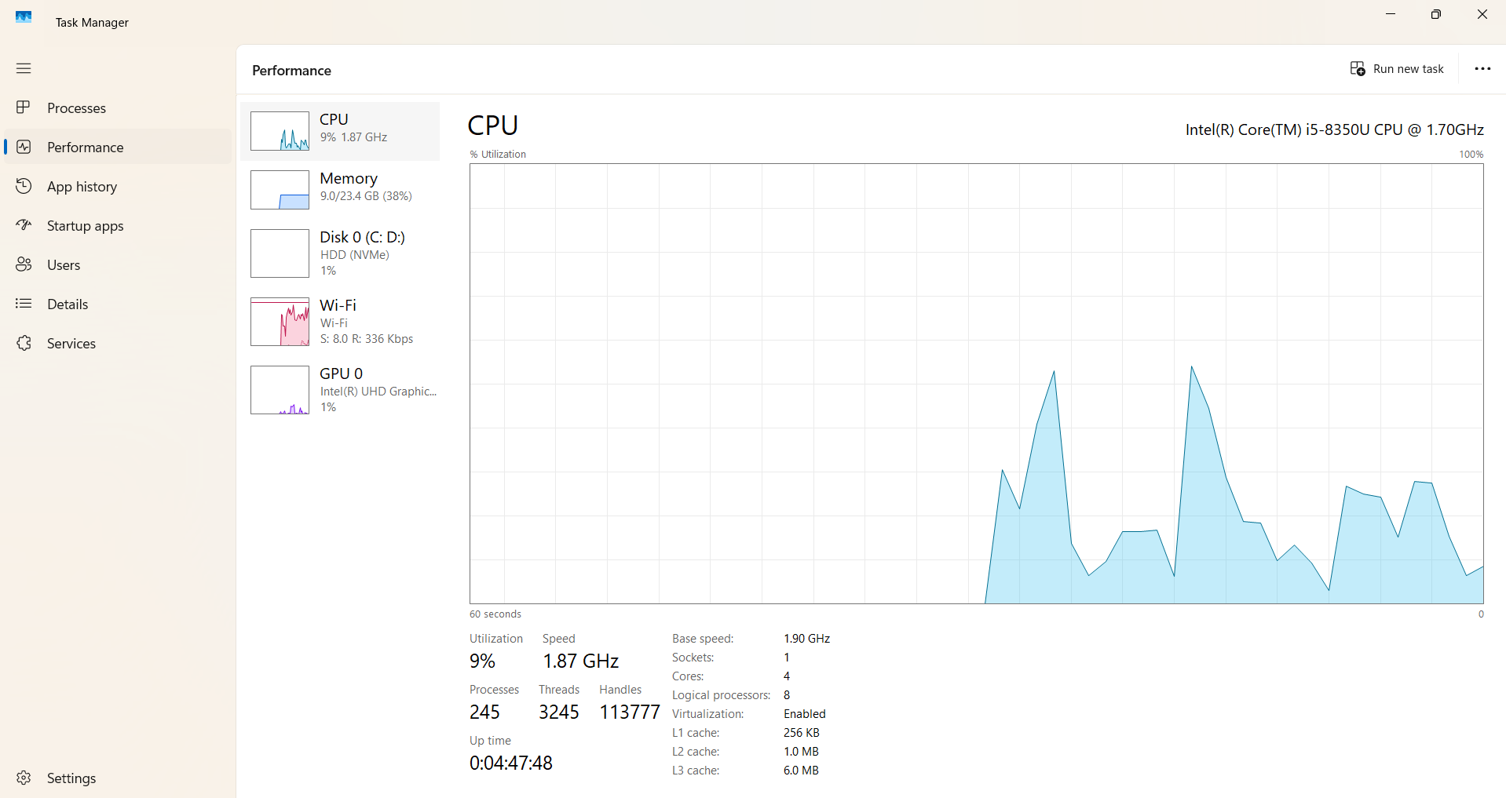

**App History** shows Information about how much CPU and network resources apps have used for your current user account.

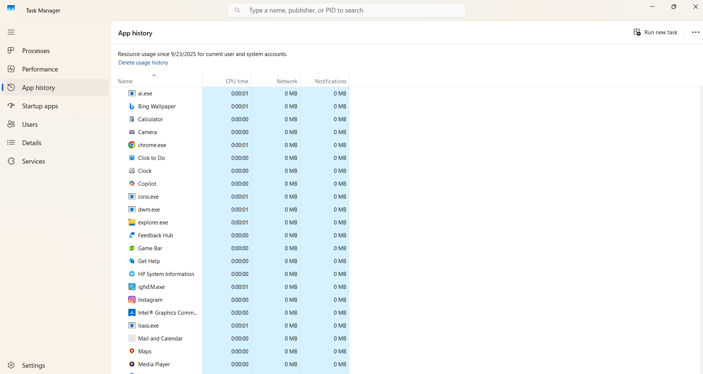

**Startup** shows a list of your startup programs, which are the applications Windows automatically start when you sign into your user account. You can disable startup programs from here, although you can also do that from Settings > Apps > Startup.

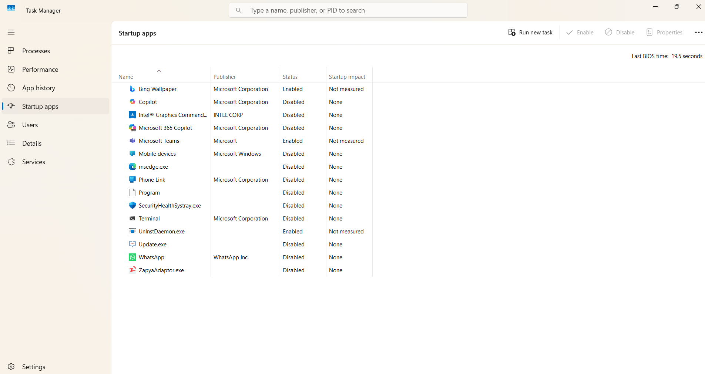

**Users** shows the user accounts currently signed into your PC, how much resources they’re using, and what applications they’re running.

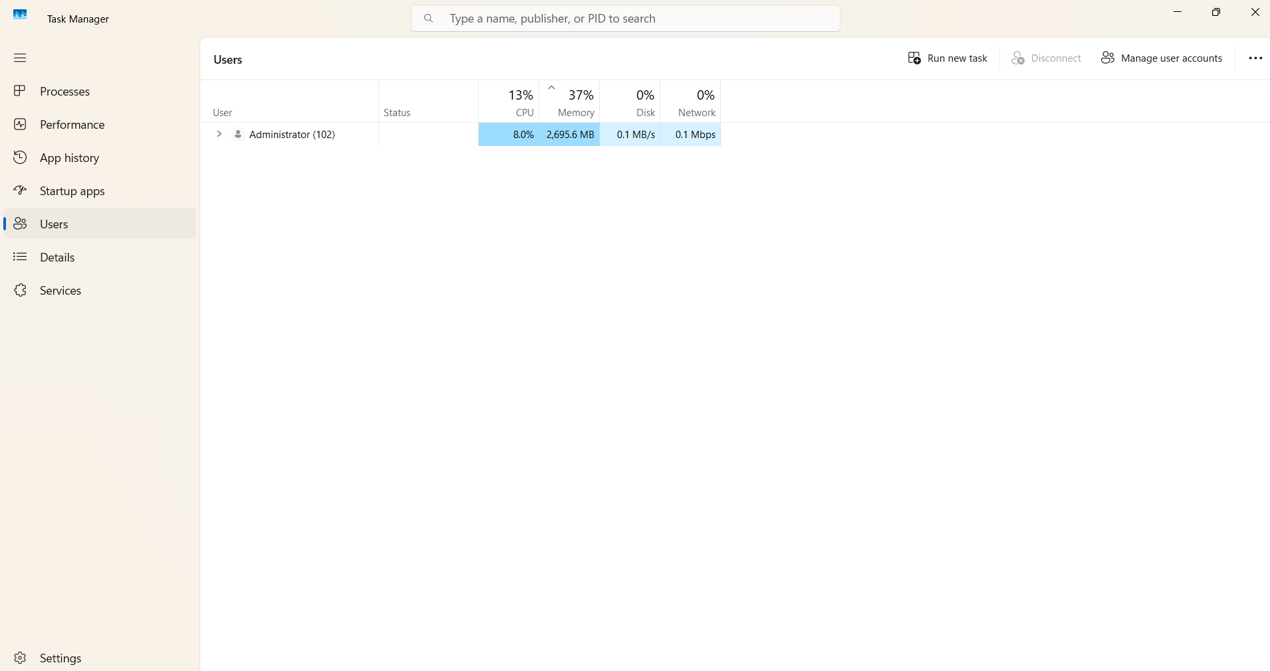

**Details** shows more detailed information about the processes running on your system. This is basically the traditional “Processes” tab from the Task Manager on Windows 7.

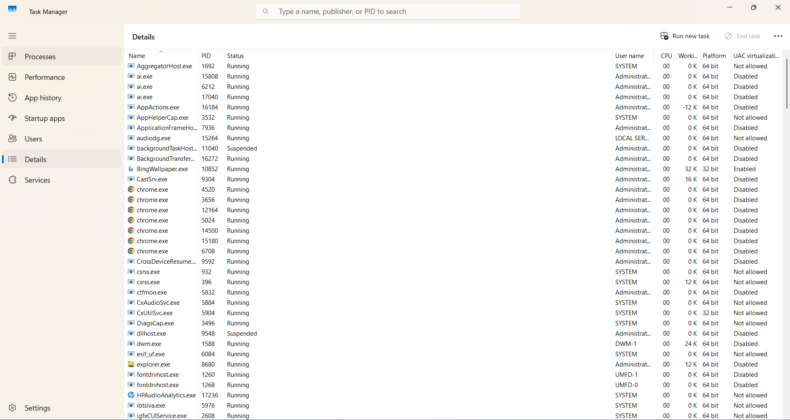

**Services** are like a helper process that runs silently in the background to keep Windows and installed applications working properly.

Think of your computer as a company:

* The user interface (what you see) is like the office reception.
* The services are the staff working in the back office — doing printing, internet connections, updates, and other tasks quietly in the background.

